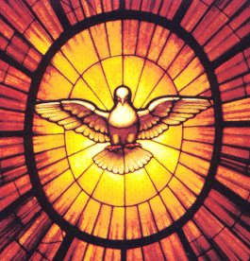
Veni Sancte Spiritus

Adult Confirmation Classes
Wednesdays, 6:30 pm – 7:45 pm via Zoom
First gathering, 2/2/22, in-person (Ed. Center, #201)
The Adult Confirmation process is a joyful interactive opportunity for Catholics to complete their full initiation into the Catholic Church. This 12-week journey emphasizes the basics of Catholic teaching, respecting the adult audience’s many concerns, questions and responsibilities.

The top reason adults hesitate to pursue this sacrament is a fear of not knowing enough. Please don't let that stop you. That's what we're here for! We'd love to accompany you on the journey so that you can live in the fullness of our beautiful Catholic faith.

Contact the Faith Formation Office to register.
(530-677-3234, option 5)

