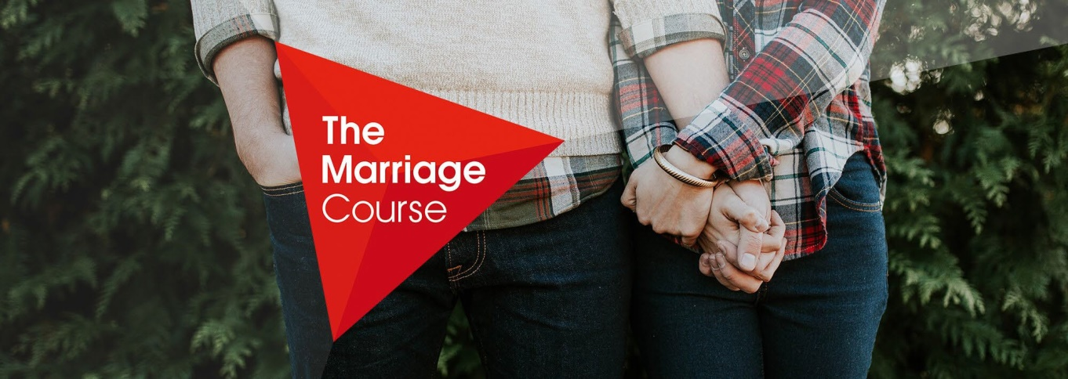

TIME & SPACE TO FOCUS ON YOUR RELATIONSHIP
THE ALPHA MARRIAGE COURSE
THIS COURSE IS FREE!

Each Sunday: November 8th - December 20th
7:00 – 9:00 PM VIA ZOOM
SESSION HOSTS: Deacon Dan & Terri Haverty and PAUL & STEPHANIE FRANCOIS
To Register Please Email: paulandsteph@pacbell.net

The Marriage Course is a series of seven sessions, designed to help couples invest in their relationship and build a strong marriage.

The course helps couples to:
- Communicate more effectively
- Understand each other's needs
- Resolve conflict
- Recognize how upbringing affects your relationship
- Develop greater sexual intimacy

Alpha Marriage Course Trailer: https://www.youtube.com/watch?v=qba2wYpXgUs

